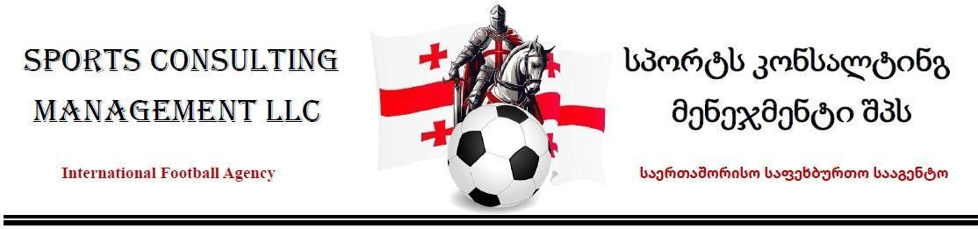

PAYMENT AGREEMENT
Date: 11 July 2026 Place: Tbilisi, Georgia Between:
LLC SPORTS CONSULTING MANAGEMENT
Represented by its Director KARTLOS RUKHAIA
(hereinafter referred to as the “Agency”) Mr. Jubhele Shange
Parents/Guardians of SHANGE HOMOLEMO AMUNENE Passport No. A11383030
Represented by COCKRILL GEOFFRY MALVIN Passport No. A05776320
(hereinafter referred to as the “Parents and Representative”)

Purpose of the Agreement
The Parents and Representative acknowledge that the Agency is arranging and facilitating the placement of SHANGE HOMOLEMO AMUNENE with either FC Iveria or FC Iberia 2010 in Georgia.
The change from the previously discussed club option has been made after further evaluation in order to provide the Player with a stronger environment for development, better exposure, and a clearer pathway for progression. The Agency believes that one of these two clubs offers

the best current opportunity for the Player’s growth and future career advancement.

Payment Agreement
The Parents and Representative agree that the total service fee payable to the Agency is EUR 13,500 (Thirteen Thousand Five Hundred Euros).
The Parties agree that the payment shall be made in two installments:
Payment Amount
First Payment – on or before 31 July 2026 EUR 6,750 Second Payment – on or before 31 August 2026 EUR 6,750 Total EUR 13,500
Payments may be made by mutually agreed methods of transfer.

Authorization to Proceed
By signing this Agreement, the Parents and Representative authorize the Agency to:
  - Begin and continue negotiations with the selected club.
  - Proceed with registration and administrative processes.
  - Arrange accommodation and placement for the Player.
  - Finalize the club contract with either FC Iveria or FC Iberia 2010.

Club Placement
The Parents and Representative acknowledge and agree that the Player will be signed with one of the following clubs, depending on the final agreement and registration process:
  - FC Iveria
  - FC Iberia 2010

Contract Terms
The football contract arranged by the Agency will include the following principal terms:
  - Contract Duration: Six (6) months, with the possibility of an additional six (6) months depending on performance, discipline, fitness, and overall contribution to the club.
  - Monthly Salary: 500 GEL.

  - Accommodation: Private apartment provided by the club.
  - Transfermarkt: The Player shall be listed on Transfermarkt.
  - Possible Salary Increase: During the extended period, the club may negotiate an
increase in the Player’s monthly salary based on performance and value to the team.

Supervision and Welfare
The Agency acknowledges that the Player is still a young developing footballer and requires guidance and supervision. The Agency will remain involved throughout the placement process, monitor the Player’s welfare, check on the accommodation arrangements, and assist with his adaptation to the Georgian football environment.

Acknowledgement
The Parents and Representative confirm that they have read and understood this Agreement and voluntarily consent to the Agency proceeding with the placement and registration process for SHANGE HOMOLEMO AMUNENE.

SIGNATURES
For the Agency
Signature required
LLC SPORTS CONSULTING MANAGEMENT
Director: KARTLOS RUKHAIA
Signature: Date

Parent / Guardian 1
Signature required
Name: Jubhele Shange
Signature: Date 13 July 2026

Player’s Representative
Signature required
Name: COCKRILL GEOFFRY MALVIN
Passport No.: A05776320
Signature: Date

